AWS: Oracle Database Backup to S3

**Pre-Requisites**

Using the Oracle Secure Backup Cloud Module for Amazon S3 requires an Amazon Web Services account, IAM Role with Full Access Policy to S3 and the OSB Cloud Module for Amazon S3 software library and associated files (which get installed using **osbws_install.jar**).

Before running the OSB Cloud Module for Amazon S3 installer, verify that the following prerequisites are met.

1. The OSB Cloud Module for Amazon S3 installer requires Java 1.5 or higher to run.

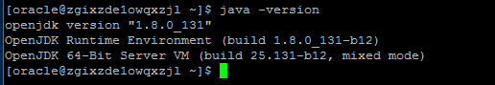

1. Download the OSB Cloud Module for Amazon S3 installer (**osbws_installer.zip**) through Jfrog to EC2 database server.

*<Jfrog details need to be updated>*

1. 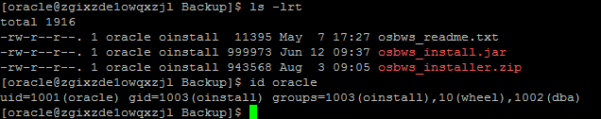Copy and unzip the OSB Cloud Module for Amazon S3 installer archive to a staging directory as the Oracle software owner (typically oracle).
2. Create a directory for the secure Oracle wallet. The Oracle wallet will be created by the installer and used to store your AWS S3 credentials.

|  |
| --- |
|  |

1. The authentication method used by Amazon S3 relies on the client's system time being similar to Amazon S3's time. In this case, the client is the machine where you run the OSB Web Services library. Amazon S3 time is Coordinated Universal Time (UTC), so you must ensure that the system time on your client is within a few minutes of UTC.

**Install Oracle Secure Backup Cloud Module for Amazon S3**

Install and configure Oracle Secure Backup Cloud Module for Amazon S3 using the steps described in this section.

1. **The OSB Cloud Module for Amazon S3 Installer**

Verify the environment by listing the valid set of input parameters for the OSB Cloud Module for Amazon S3 installer along with their descriptions.

You can also review the osbws_readme.txt file for more details.

1. **Run OSB Cloud Module for Amazon S3 Installer Script**

Run the OSB Cloud Module for Amazon S3 installer script as like below. The installer will download the software library and configure the environment for running Oracle database backups to the Cloud (Amazon S3).

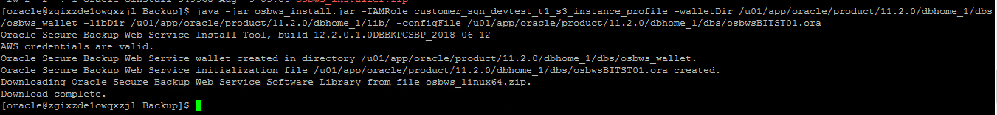

|  |
| --- |
| java -jar osbws_install.jar -IAMRole **customer_sgn_devtest_t1_s3_instance_profile** -walletDir /u01/app/oracle/product/11.2.0/dbhome_1/dbs/osbws_wallet -libDir /u01/app/oracle/product/11.2.0/dbhome_1/lib/ -configFile /u01/app/oracle/product/11.2.0/dbhome_1/dbs/osbws<SID>.ora |

Without IAM role and provide details with s3 details and location using aws secret key and access key

|  |
| --- |
| java -jar osbws_install.jar -AWSID XxXxX -AWSKey XxXxX -walletDir $ORACLE_HOME/osbws_wallet -libDir $ORACLE_HOME/lib -- -configFile $ORACLE_HOME/dbs/osbws<SID>.ora -location ap-southeast-2 -awsEndPoint  s3-ap-southeast-2.amazonaws.com  -otnUser [Saisumanth.reddy@sgn.uk.co](mailto:Saisumanth.reddy@sgn.uk.co) -otnPass |

Parameters:

  -AWSID:       AWS Access Key   -AWSKey:      AWS Secret Access Key  
  
  -walletDir:   Location where Backup Module will store AWS keys  
  
  -libDir:      Location where Backup Module libraries will be installed  
  
  -location:    This is AWS S3 location where you want to put your backups into.   
                Value for this parameter must be a valid Region from Amazon Regions.  
                In this example "ap-southeast-2" which is region for "Asia Pacific (Sydney)" has been used  
  -awsEndPoint: This should be valid end-point from location AWS region specified by "location" parameter  
                In this example "s3-ap-southeast-2.amazonaws.com" has been used which is one of the end-points in ""Asia Pacific (Sydney)""

Optional: -otnUser:     OTN Account   -otnPass:     OTN Password

1. **Fix Media Management Library Loading Error**

The installer does not create the default media management library symbolic link for the OSB Cloud Module for Amazon S3 media management library. This results in the following RMAN error when attempting to allocate a channel of type sbt:

|  |
| --- |
| RMAN-00571: ===========================================================  RMAN-00569: =============== ERROR MESSAGE STACK FOLLOWS ===============  RMAN-00571: ===========================================================  RMAN-03009: failure of allocate command on c1 channel at 07/05/2018 15:07:25  ORA-19554: error allocating device, device type: SBT_TAPE, device name:  ORA-27211: Failed to load Media Management Library  Additional information: 2 |

Manually create the following symbolic link for the default media management library before performing backups using the SBT interface.



|  |
| --- |
| ln -s /u01/app/oracle/product/11.2.0/dbhome_1/lib/libosbws.so $ORACLE_HOME/lib/libobk.so |

1. **Modify Oracle Recovery Manager's Media Management Configuration**

The next step is to change the Oracle Recovery Manager (RMAN) media management configuration to redirect traditional tape backups to the Cloud (Amazon S3) in the RMAN repository. This avoids having to provide the configuration information each time a backup is invoked. The following example is for an Oracle 11*g* Release 2 database.

Make certain to add a space after entering each line of the configure channel device type sbt parms command. Needed to specify the command on multiple lines to make it easier to read. Optionally change the default device type to SBT_TAPE.



|  |
| --- |
| RMAN :-  configure channel device type 'sbt_tape' parms 'SBT_LIBRARY=/u01/app/oracle/product/11.2.0/dbhome_1/lib/libosbws12.so SBT_PARMS=(OSB_WS_PFILE=/u01/app/oracle/product/11.2.0/dbhome_1/dbs/osbws<SID>.ora)';  configure default device type to 'sbt_tape'; |

1. **Change the Config file to point to S3 Bucket**

By Default the config file osbws<SID>.ora will point to US location, change to our own region, please check the below example.

Default File:

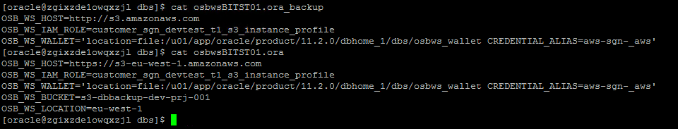

Changed File:

|  |
| --- |
|  |

Note: For IAM policy and S3 Bucket naming, Please find in Appendix

Note: file can be used in rman script for any other databases in same Oracle Home. For this reason,we can rename it to osbwsCONFIG.ora so that name is generic and there is no dependency to any of databases

**Perform an Oracle Database Backup to the Cloud**

**Check the Connectivity between EC2 and S3**

We can check the connectivity between EC2 and S3 using sbttest utility as like below, Once its successful proceed to run DB backup.

|  |
| --- |
| Sbttest <samplefile> -dbname <SID> |

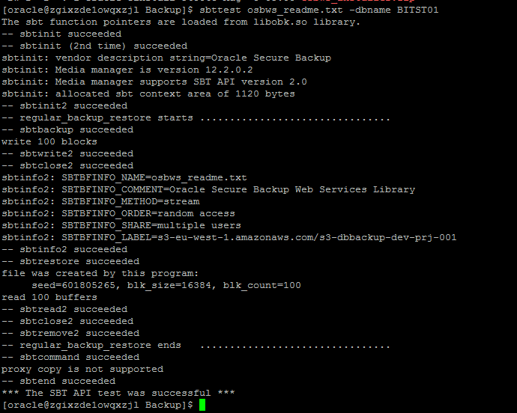

At this point, you can issue your usual RMAN backup and restore commands.

**RMAN Backup Commands**

|  |
| --- |
| Full Backup:  ============  run {  allocate channel dev1 DEVICE TYPE 'SBT_TAPE' PARMS 'ENV=(OSB_WS_PFILE=/u01/app/oracle/product/11.2.0/dbhome_1/dbs/osbws<SID>.ora),SBT_LIBRARY=/u01/app/oracle/product/11.2.0/dbhome_1/lib/libosbws.so';  allocate channel dev2 DEVICE TYPE 'SBT_TAPE' PARMS 'ENV=(OSB_WS_PFILE=/u01/app/oracle/product/11.2.0/dbhome_1/dbs/osbws<SID>.ora),SBT_LIBRARY=/u01/app/oracle/product/11.2.0/dbhome_1/lib/libosbws.so';  allocate channel dev3 DEVICE TYPE 'SBT_TAPE' PARMS 'ENV=(OSB_WS_PFILE=/u01/app/oracle/product/11.2.0/dbhome_1/dbs/osbws<SID>.ora),SBT_LIBRARY=/u01/app/oracle/product/11.2.0/dbhome_1/lib/libosbws.so';  sql 'alter system switch logfile';  sql 'alter system switch logfile';  sql 'alter system switch logfile';  backup as compressed backupset database;  sql 'alter system archive log current';  backup as compressed backupset archivelog all not backed up;  delete archivelog all completed before 'sysdate-1';  backup current controlfile;  }  Archive log Backup:  =================  run {  allocate channel ch1 DEVICE TYPE 'SBT_TAPE' PARMS 'ENV=(OSB_WS_PFILE=/u01/app/oracle/product/11.2.0/dbhome_1/dbs/osbws<SID>.ora),SBT_LIBRARY=/u01/app/oracle/product/11.2.0/dbhome_1/lib/libosbws.so';  allocate channel ch2 DEVICE TYPE 'SBT_TAPE' PARMS 'ENV=(OSB_WS_PFILE=/u01/app/oracle/product/11.2.0/dbhome_1/dbs/osbws<SID>.ora),SBT_LIBRARY=/u01/app/oracle/product/11.2.0/dbhome_1/lib/libosbws.so';  allocate channel ch3 DEVICE TYPE 'SBT_TAPE' PARMS 'ENV=(OSB_WS_PFILE=/u01/app/oracle/product/11.2.0/dbhome_1/dbs/osbws<SID>.ora),SBT_LIBRARY=/u01/app/oracle/product/11.2.0/dbhome_1/lib/libosbws.so';  sql 'alter system switch logfile';  sql 'alter system switch logfile';  sql 'alter system switch logfile';  backup as compressed backupset archivelog all not backed up;  sql 'alter system archive log current';  backup current controlfile;  backup spfile;  } |

**RMAN Restore Command**

|  |
| --- |
|  |
|  |
| startup force mount;  run {  allocate channel dev1 DEVICE TYPE 'SBT_TAPE' PARMS 'ENV=(OSB_WS_PFILE=/u01/app/oracle/product/11.2.0/dbhome_1/dbs/osbws<SID>.ora),SBT_LIBRARY=/u01/app/oracle/product/11.2.0/dbhome_1/lib/libosbws.so';  allocate channel dev2 DEVICE TYPE 'SBT_TAPE' PARMS 'ENV=(OSB_WS_PFILE=/u01/app/oracle/product/11.2.0/dbhome_1/dbs/osbws<SID>.ora),SBT_LIBRARY=/u01/app/oracle/product/11.2.0/dbhome_1/lib/libosbws.so';  allocate channel dev3 DEVICE TYPE 'SBT_TAPE' PARMS 'ENV=(OSB_WS_PFILE=/u01/app/oracle/product/11.2.0/dbhome_1/dbs/osbws<SID>.ora),SBT_LIBRARY=/u01/app/oracle/product/11.2.0/dbhome_1/lib/libosbws.so';  restore database;  recover database;  alter database open;  } |

**Full Backup Logs:**

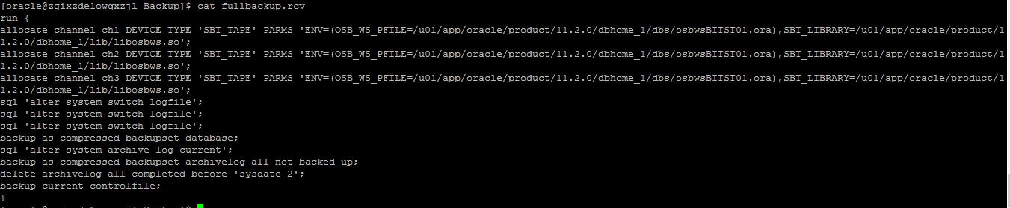

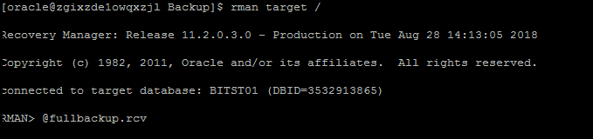

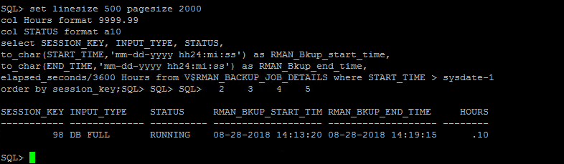

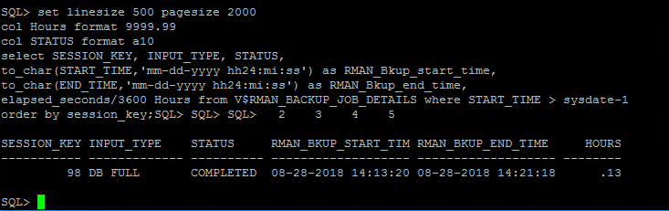

**Archive Backup logs:**

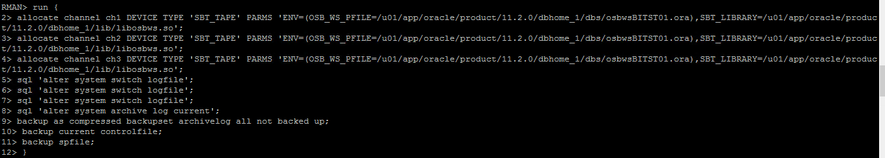

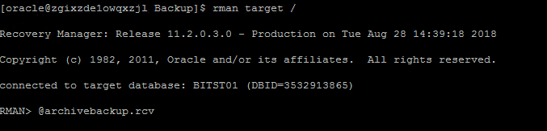

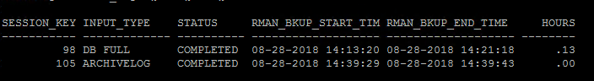

**Appendix**

1. IAM Role Policy Details

Need to send a mail to DevOps team to get the role to be created

“customer_sgn_<env>_<tier>_s3_instance_profile”

1. S3 Bucket Creation

Need to send mail to DevOps Team to create S3 bucket and assign S3 Full Access policy to EC2 instance.